

**CSM 3401 Internet of Things**

**Group Project**

|  |  |
| --- | --- |
| **Prepared by:** | |
| **Teoh Kok Lin** | **(S51453)** |
| **Tang Choon Yew** | **(S52287)** |

|  |
| --- |
| **Prepared for:** |
| **Dr. Rabiei Mamat** |

|  |  |
| --- | --- |
| **Faculty name:** | **Faculty of Ocean Engineering Technology and Informatics** |

**Contents**

**Executive Summary** 3

**Introduction** 4

**Problem Statement** 5

**Objective** 6

**Problem Solution** 7

**Methodology** 8

**Result and Discussion** 12

**Conclusion** 13

**Appendix 1: Source Code** 14

**Appendix 2: Screenshots of Output** 17

**Appendix 3: Task Distribution among group members** 20

**Appendix 4: PowerPoint presentation Slide** 21

**Appendix 5: Video** 26

# **Executive Summary**

This project contains 2 parts which are project 1 and project 2. Project 1 is to control the dimming of LED by using a potentiometer with appropriate python code. Project 2 is to design a circuit with appropriate python code to store current temperature and humidity data with DHT11/12 to favoriot cloud through Wi-Fi network so that we could receive the notification via SMS when environment temperature exceeds 29 degree or when relative humidity falls below than 70. ESP32 development board which supports the micropython framework is used in both projects. Micropython is used to program the development board with uPyCraft IDE.

# **Introduction**

The Internet of Things also known as IoT refers to the billions of physical devices around the world that are now connected to the internet, all collecting and sharing data. Simple tasks such as switching the lightbulb with the smartphone can be done thanks to the small IoT component inside it.

Now, the smart cities projects that build and design the entire region with sensors in mind have enabled the management to monitor and control the entire region with ease. Hence, the IoT technology is now a leading revolution which has changed many aspects of our daily life.

In this project, we will apply what we have learnt from the Internet of Things subject to the project by designing two types of circuit that incorporate IoT on it. The first project is to design a circuit that can dim the LED when necessary and the latter is to monitor the temperature and relative humidity.

# **Problem Statement**

Following are the problem statement for project 1 and project 2:

**Project 1:**

Light is now part of our daily life but sometimes a softer light is needed especially when a more comforting and relaxing atmosphere is required. Hence, a switch to control the intensity of the LED light is required.

**Project 2:**

In a laboratory experiment, controlling and monitoring temperature and relative humidity in a specific range is time consuming. Hence a monitoring system to monitor temperature and relative humidity is required.

# **Objective**

The following are the objectives of project 1 and project 2:

**Project 1:**

* To design a circuit that can control the light intensity of the LED.
* To use appropriate python code in designing the circuit.

**Project 2:**

* To design a circuit that can read current temperature and relative humidity.
* To use appropriate python code to establish Wi-Fi connection for ESP32 and save the data to favoriot cloud.

# **Problem Solution**

The following are the problem solution for project 1 and project 2:

**Project 1:**

This project is carried out to adapt the change of the purpose when using a room. The control of the intensity of LED’s light is by adjusting the potentiometer. By turning the shaft of the potentiometer, the resistance in the circuit changed. Hence, the voltage flowing through the LED becomes lower which lowers the intensity of the LED's light as a result.

**Project 2:**

To monitor the relative humidity and temperature in the laboratory experiment, a circuit that contains DHT11/12 has been designed. The temperature in this project is set at 29 degree and relative humidity is set at 70. Hence if the temperature or the relative humidity exceed either of the values, a notification will be sent to the owner.

# **Methodology**

The following are the methodologies of project 1 and project 2:

**Project 1:**

The circuit of project 1 is set up as shown in the picture.

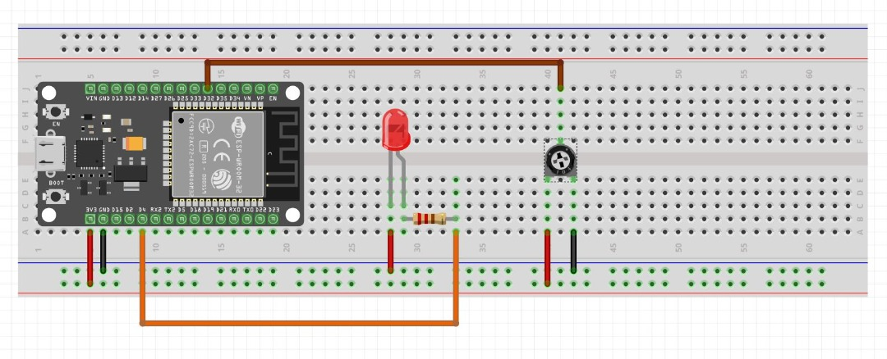

The potentiometer will serve as a voltage regulator or controller for LED. By turning the potentiometer, one can increase or decrease the resistance in the circuit in order to control the brightness of the LED. The resistor in the circuit is used to reduce the current flow towards the LED as it may damage the LED. The ESP32 development board will act as an intermediate controller which manages the brightness of the LED.

Flow chart of project 1:

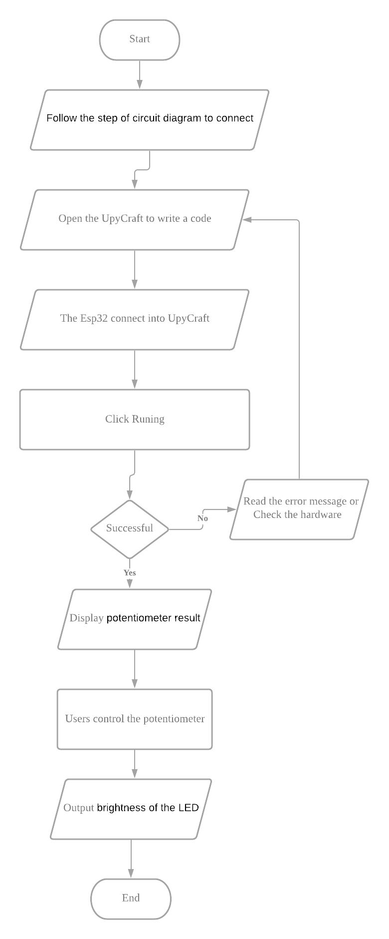

**Project 2:**

The circuit of project 2 is set up as shown in the picture.

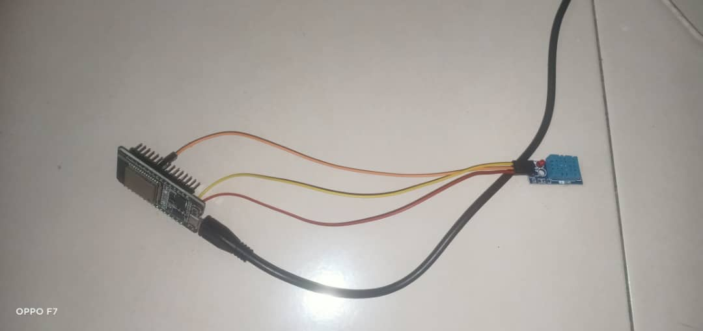

The wire of orange to connect pin D18. The next is a wire of yellow and red connected to GND and 3.3v on ESP32 respectively.

Flow chart of project 2:

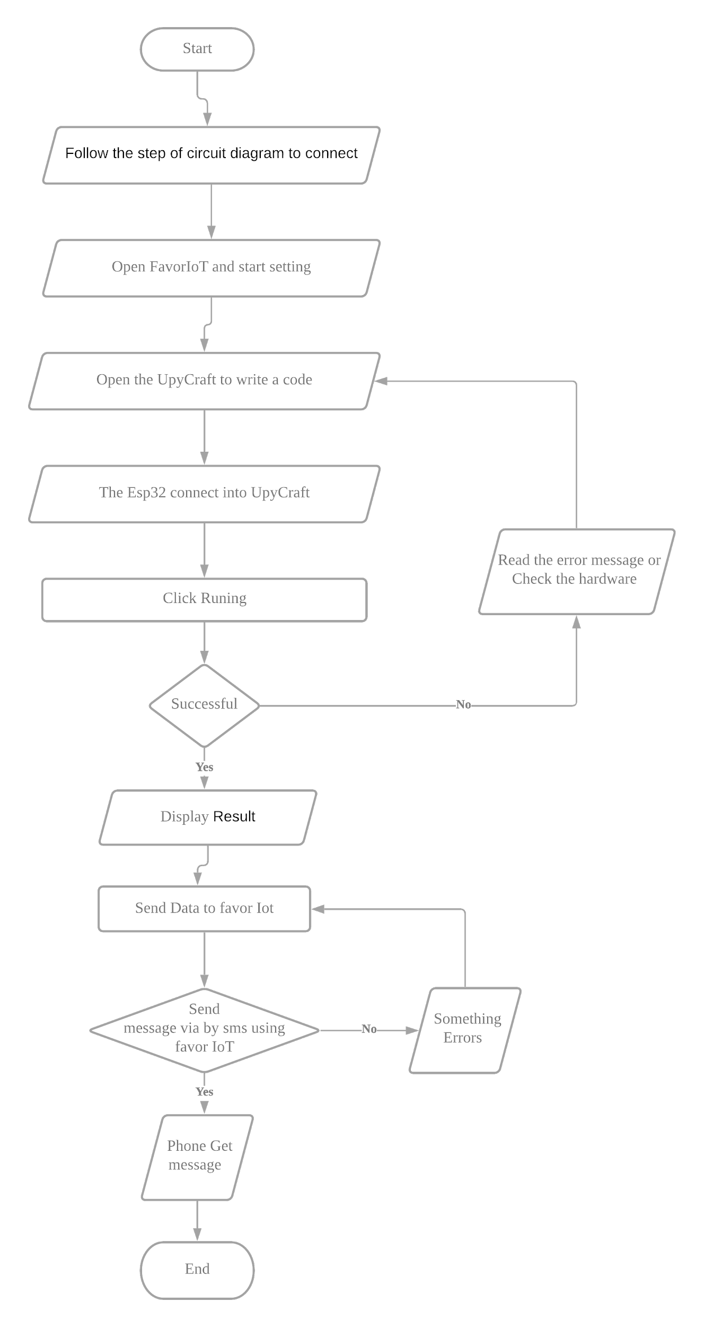

# **Result and Discussion**

This section covers the results and discussions of both project 1 and project 2.

**Project 1**

Result:

If the analog value reaches the highest, the LED light will slowly become dimmer and dimmer. While the analog value is equal to zero, the LED light is the brightest. While increasing the analog value, the LED light will slowly fade away.

Discussion:

If the LED is directly connected to the potentiometer without the ESP32 development board, the control of the brightness of the LED will be much less accurate as it depends on the resistance of the potentiometer. But if the situation is opposite, then the control of the brightness of the LED will be much more accurate because the ESP32 board can determine the level of the LED brightness. The reason is that the microcontroller can help to neglect the voltage output for the LED which is more flexible than manual control of the brightness.

**Project 2**

Result:

ESP32 has successfully connected to the internet. The temperature and relative humidity data is then sent and saved in the data stream of the favoriot account every 5 second. If the temperature or relative humidity values exceed the preset values of either 29 and 70 respectively, a notification of SMS is then sent to the owner’s phone.

Discussion:

This project required the development board of ESP32 to be connected to the internet. The temperature and the relative humidity data of the board is then published to the favoriot through MQTT client server. User access tokens are needed to be retrieved from the connected device. The data will then be saved in the data stream of favoriot account. An SMS notification will then be sent to the owner’s phone when one of the conditions is met.

# **Conclusion**

As a conclusion, the intensity of the LED’s light can now be controlled by turning the potentiometer, increasing the circuit’s resistance and hence lowering the intensity of the LED’s light. The monitoring of temperature and relative humidity also fulfill the requirement by sending a notification SMS to the owner if temperature or relative humidity have exceeded the preset values. Hence this has proven that with IoT technology, life has been made much easier and efficient.

# **Appendix 1: Source Code**

**Project 1:**

from machine import Pin, ADC, PWM

from time import sleep

led = PWM(Pin(4), 5000)

pot = ADC(Pin(32))

pot.width(ADC.WIDTH_10BIT)

pot.atten(ADC.ATTN_11DB)

print('Welcome in void loop')

while True:

pot_value = pot.read()

print(pot_value)

led.duty(pot_value)

sleep(0.01)

**Project 2:**

import time

import network

from umqtt.simple import MQTTClient

from dht import DHT11

from machine import Pin

dht11 = DHT11(Pin(18))

SERVER = "mqtt.favoriot.com"

client=MQTTClient("umqtt_client",SERVER, user="WEtulyFsNZZWFTDiGQzk9jZU9W2rwgCK", password="WEtulyFsNZZWFTDiGQzk9jZU9W2rwgCK")

wlan = network.WLAN(network.STA_IF)

wlan.active(True)

wlan.disconnect()

if not wlan.isconnected():

print("connecting to network")

wlan.connect('home wirelees name', 'password wireless')

while not wlan.isconnected():

print('network config:', wlan.ifconfig())

while wlan.isconnected():

while True:

topic = "WEtulyFsNZZWFTDiGQzk9jZU9W2rwgCK/v2/streams"

client.connect()

dht11.measure()

temperature = dht11.temperature()

print(temperature,dht11.humidity())

client.publish(topic,'{"device_developer_id": "DHT11@S52287", "data":{"temperature": "%.1f","humidity": "%.1f"}}'% (dht11.temperature(),dht11.humidity()))

client.disconnect()

time.sleep(6)

# **Appendix 2: Screenshots of Output**

Project 1

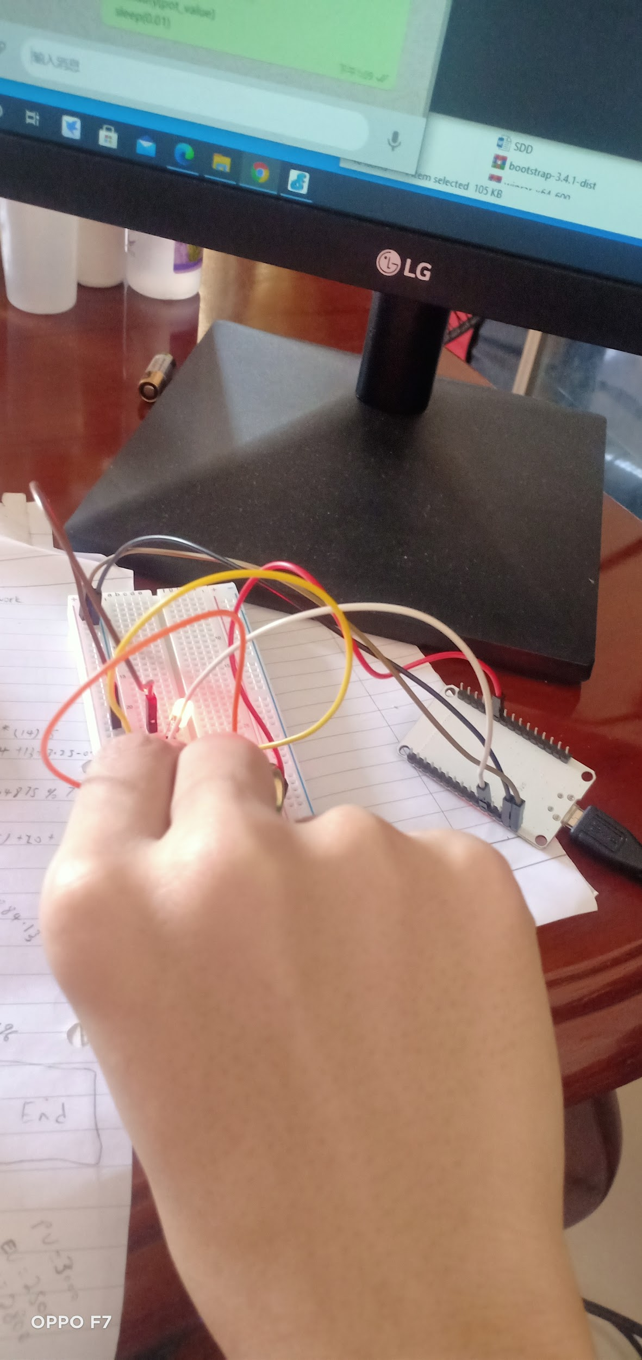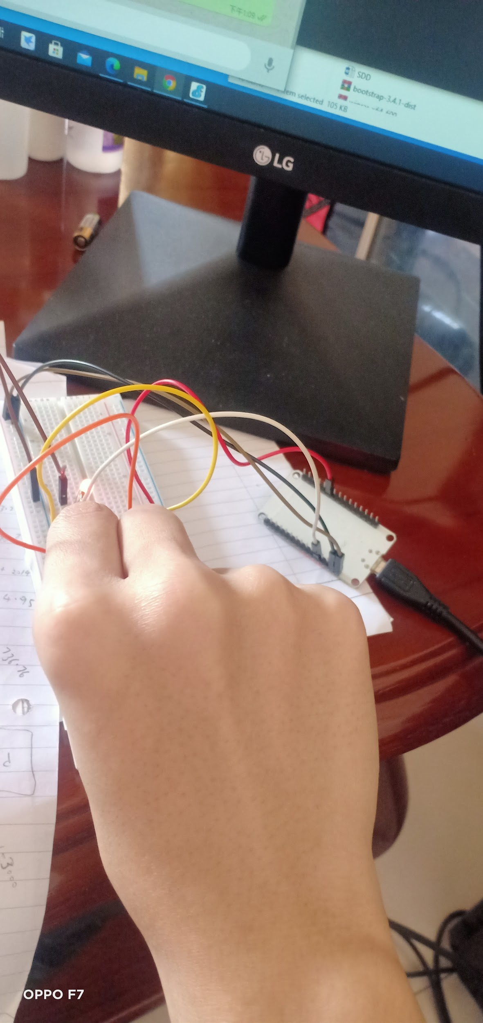

Adjusting the LED brightness

Project 2

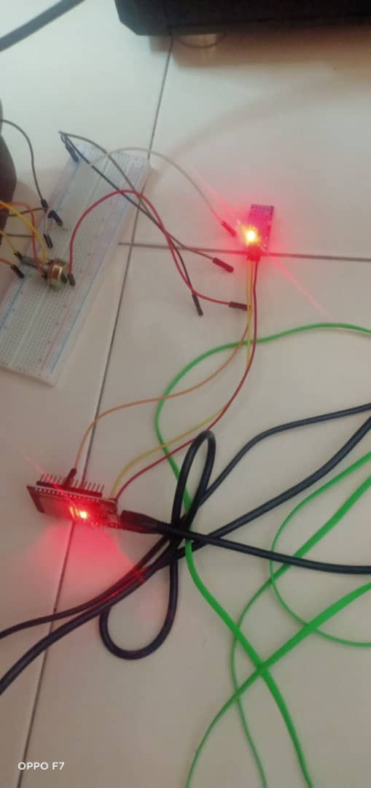

The ESP32 and DHT11 running

Project 2 Send message to email

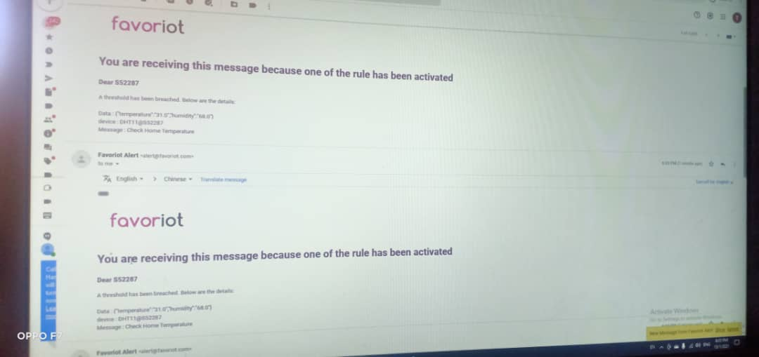

The alert message send to email

Project 2 SMS message

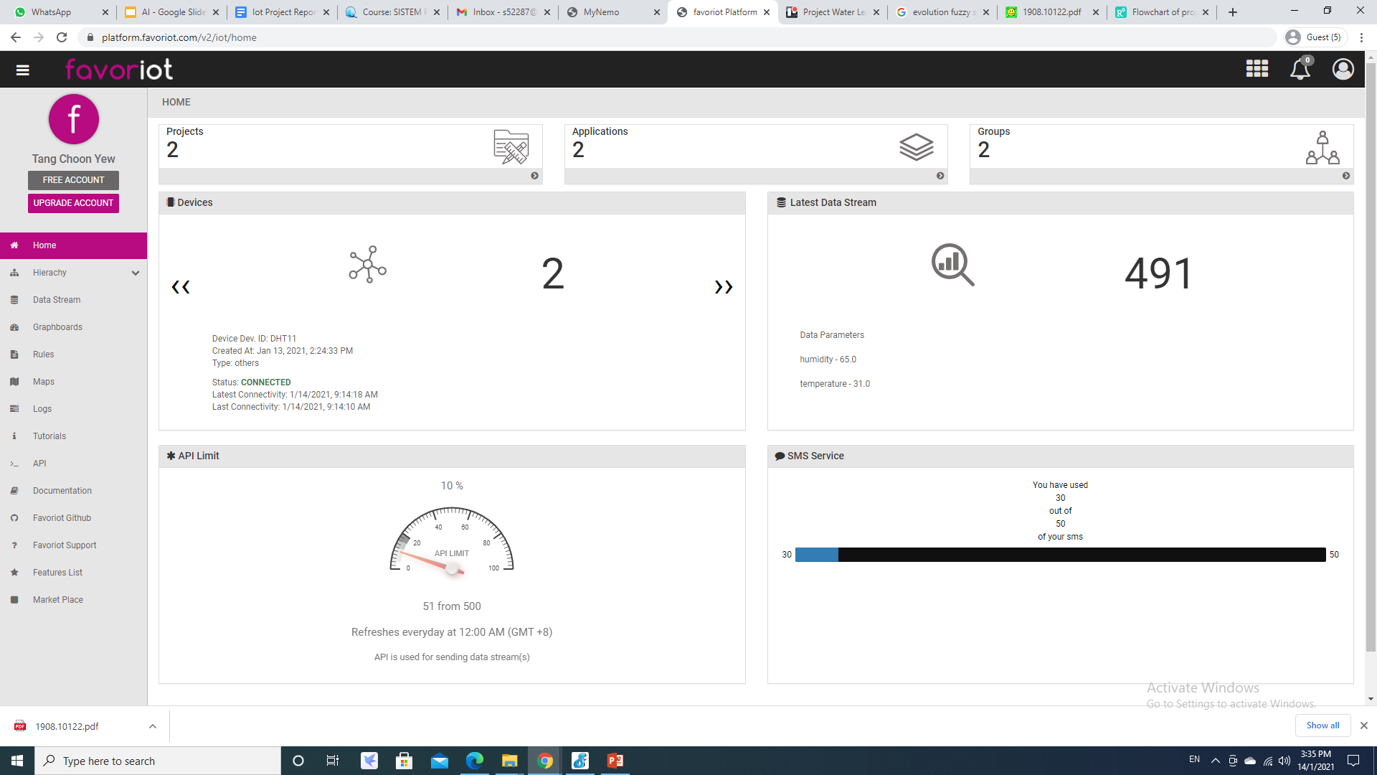

The favor IoT alert the quota SMS Service

# **Appendix 3: Task Distribution among group members**

|  |  |
| --- | --- |
| Name | Task Distributed |
| Tang Choon Yew | * Project 1 * Project 2 * Discussion on result |
| Teoh Kok Lin | * Discussion on result * Documentation |

# **Appendix 4: PowerPoint presentation Slide**

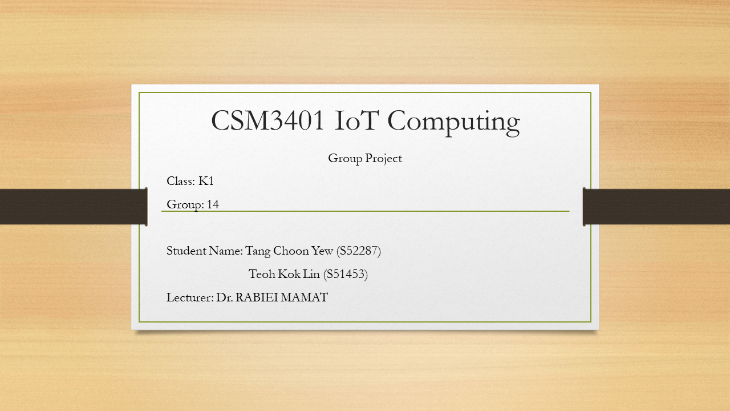

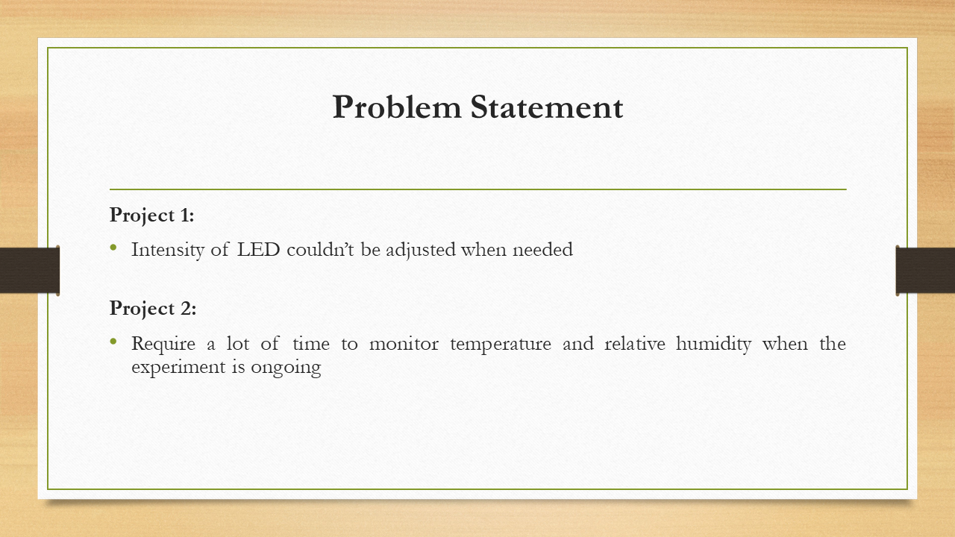

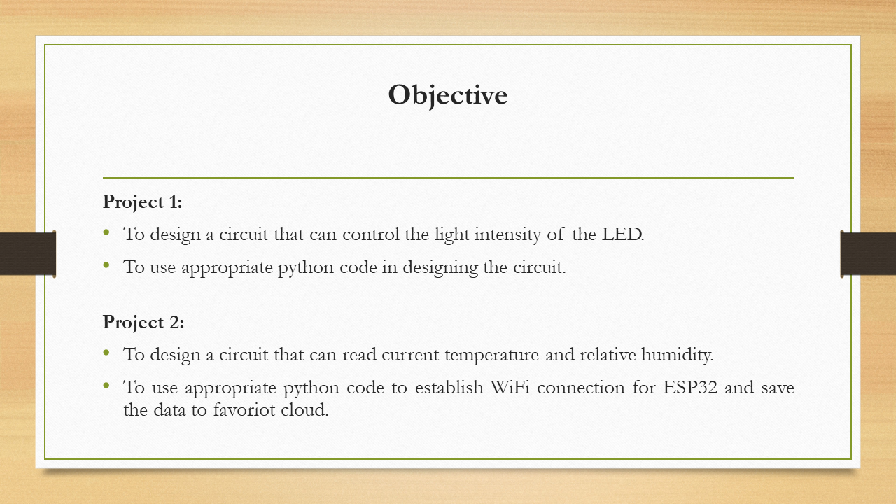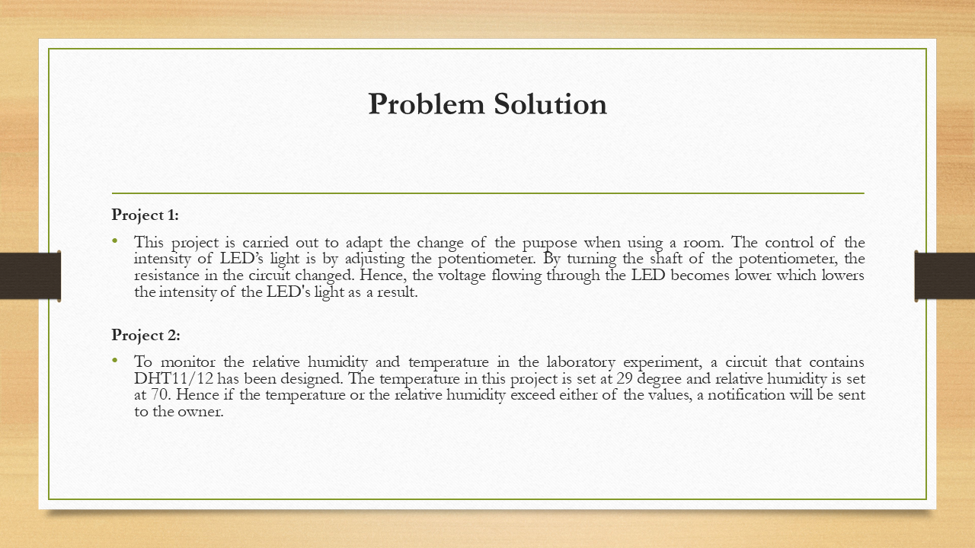

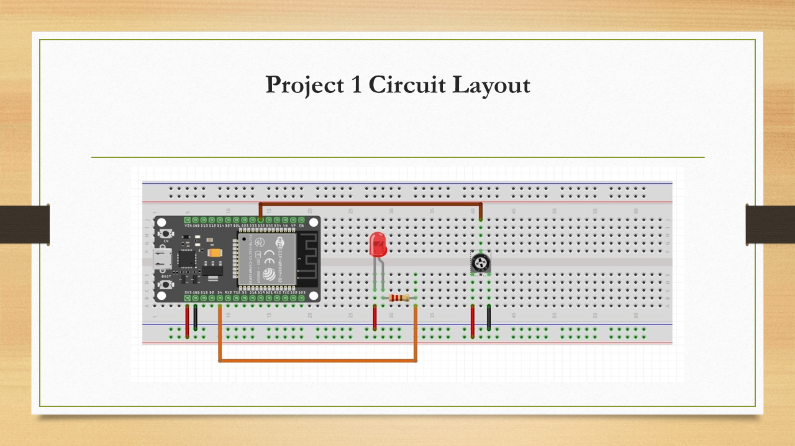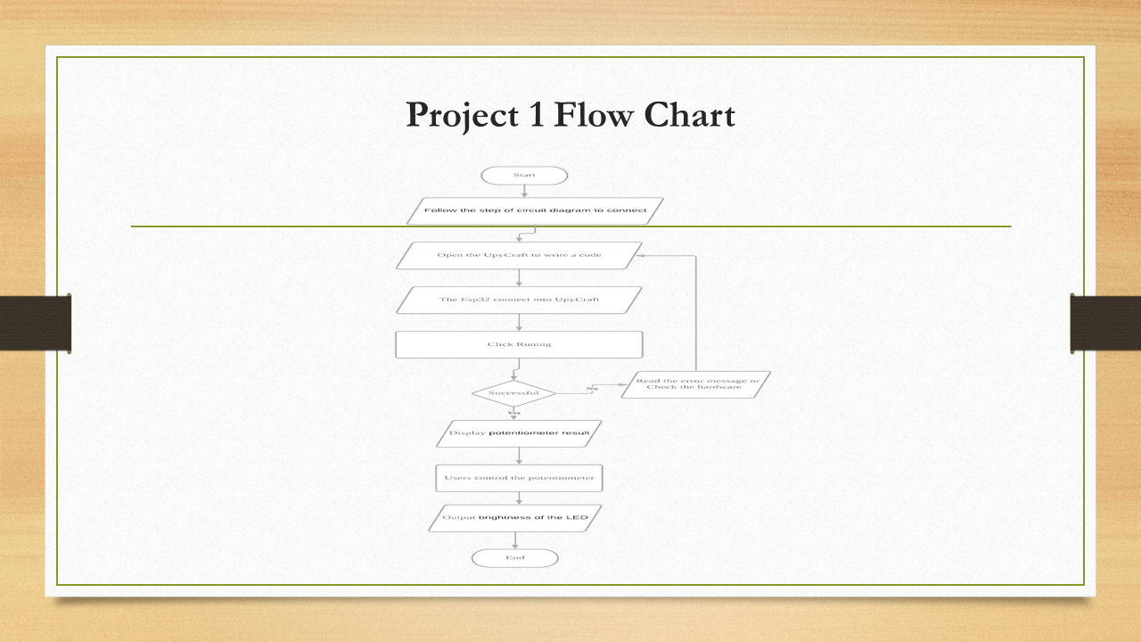

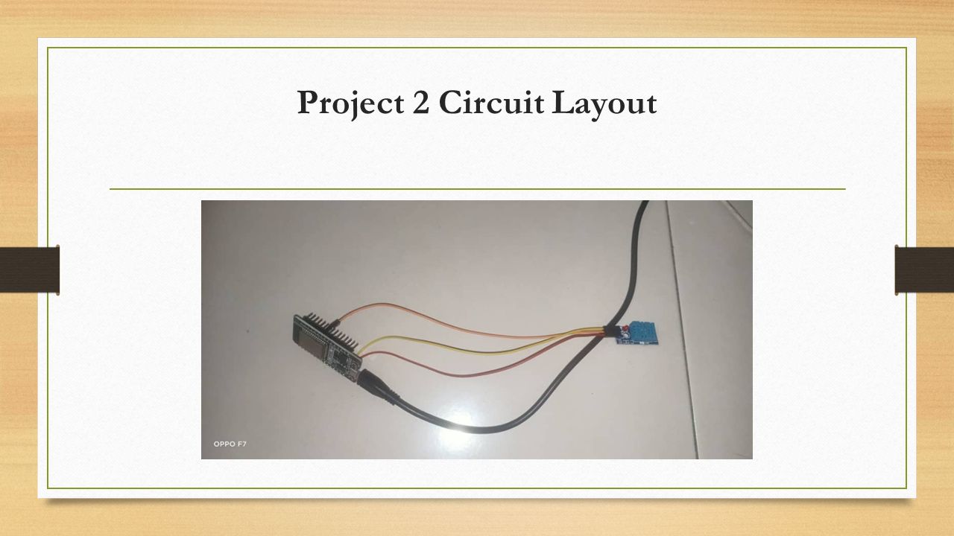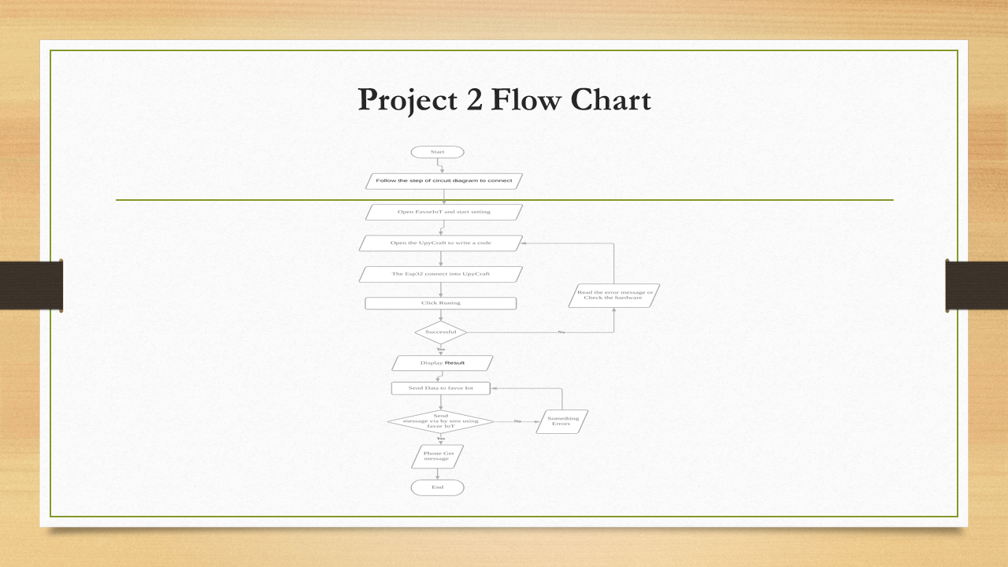

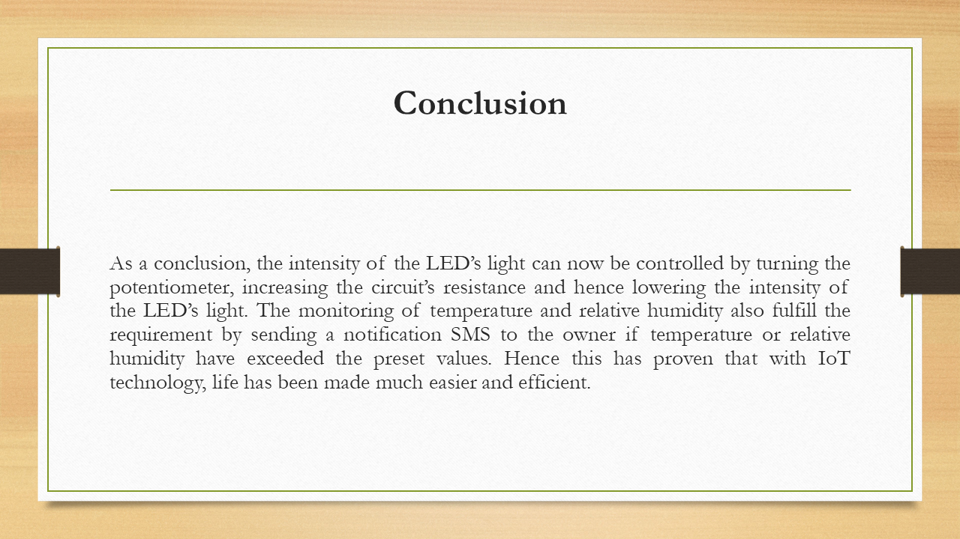

# **Appendix 5: Video**

1. **Project 1 and 2 demonstration**

**https://youtu.be/v7OL_4y3qKo**

1. **Project Presentation:**

**https://youtu.be/52L_NNu8koc**